10.23

Gotten rid of output file.

Using morningOutput for morningtask run only now.

AM started to crash which is not a good sign. Wait until you add.

Following last fri’s pm crash, today’s morning remained weak.

Whole market is feeling weak like in Jul, be careful with adding pos.

晌午饭吃了个煎饼果子，一碗胡辣汤，一杯豆浆，舒服！（悟空）

10.24.2017

Ptf underperforming broad based indices.

H share open and close trading opportunities with top sharpe players.

In the spirit of trading around the position. You should have some HK stocks with highest sharpe and start trading intraday.

**Common pitfalls when you are downloading java project from github:**

1. Make sure you include derby.jar, derby client.jar, derbyrun.jar, derbytools.jar in the libraries, failure to include these will result in hibernate not working.
2. Make sure you include hibernate required files in the folder, as well as c3p0 folder in optional
3. 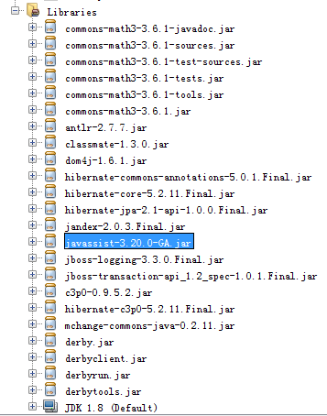
4. Make sure derby installation and database location is both correct (if database is still pointing at an old database, the new code (from github) would not be able to unblob the old data type contained in the old database, i.e. apidemo.SimpleBar would not be able to be unblobed simply since the new simplebar has been migrated to auxiliary.SimpleBar)

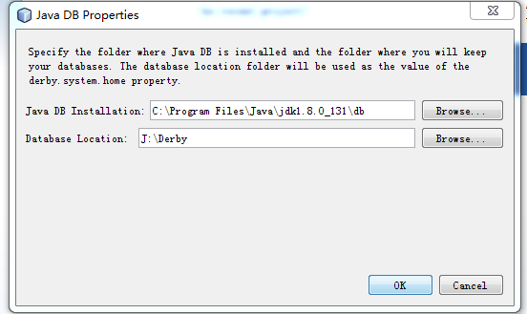

10.25

Rebalancing

Cut :

今世缘 （二流白酒）

方大炭素 (周期)

Add:

美的 （家电，城市化）

永辉超市 （百货，消费，通胀）

Added:

中国平安：保险

华大基因： 高科技

伊利： 消费

大族激光 （科技, added）

Stop adding to stocks out of the required ytd sharpe range. Cutting or not depends on you.

Focus on consumption and inflation

Strength:

华大基因 very strong in rebounding.

No家电 exposure.

No inflation exposure.

10.27

Weekend: pnl attribution

Historical pnl attribution

Weekly recap:

Trade pnl: 3537

Mtm: 35074

Gc001: 637

Net: 39248

Delta bought: 170k

Transaction charge: 77

Average pnl% per trade: 1.9%.

10.28.2017

Some Git stuff:

When you have made local changes to files AND the remote repo is ahead of you, you will need to fetch/pull from the remote repo first.

You do

Git fetch (to pull)

Git merge origin/master (to merge, some auto merging will happen but don’t worry)

Git checkout --ours A.txt B.txt (this will enable us to use the local versions of the files for which there are merge conflicts with the remote repo)

Git add A.txt B.txt

Git commit --m “merge conflicts solved”

Git push origin master.

10.29

昨天去了广州去优衣库退了羽绒服。

真是浪费时间。完全没学到新东西。12点出发到晚上回来，浪费了一天时间。

吃的东西也很一般。

有什么有价值的东西么？并没有。知识量并不对等，他也不懂当今的环境，只懂得自己有限的那点东西，还没有进步。关键因为他不看书，知识没有积累。跟一个知识不断积累的人相比，差距就太大了。投资方面，创新意识也比较差。驾驶技术也差得远。经查急刹，对于环境的判断也不行。开的太差，我就take over了。开车重要的是预判，基本不用刹车。

他说贷款的材料都是假的，都是骗贷。没有工作还能轻易的贷款，房价有多么虚。

不需要跟他们说自己在深圳。避免这些无意义的社交是有必要的。

每个礼拜见面太多了。估计几个月见一次，交流一下投资心得就可以了。

如今见面也比较尴尬，没什么说的，都是以前的陈康烂谷子。也得不到什么社交的满足感。

我对我的时间利用效率很敏感，会下意识地评判花费时间的有效性。有些事情不需要给予关注。做人势利也是没办法的事，主要看提供的效用有多大。这半年跟w也没什么来往，关系还是那样，也不需要通过不断的见面来巩固。而需要提高自己的能力。

需要做的事，首先是恢复家庭的财富地位。20年前的财富地位。

身边几个朋友的贷款都超过了存款。这一点显示了他们的头脑并不好。把自己置于不利的位置。这些决定基本反映了一个人的水平，从这些决定来看是否值得交朋友。